**IT 131 Advanced Database Systems**

**Try IT Activity**

**Name: Dinglasa Jr., Danny D.P.**

**Course, Year, & Section: BSIT - 2Arfea**

**Activity Title:**

Exploring SQL SELECT Queries with the Products Table

**Objective:**

This activity is designed to help you understand and apply basic SQL SELECT statements to retrieve and manipulate data from a database. You will practice querying the Products table using various conditions, operators, and clauses.

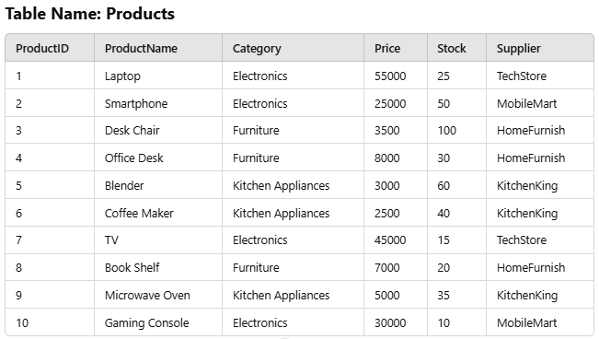

Figure 1.0

**Instructions:**

1. **Setup the Database**
   * Open your preferred SQL environment (e.g., MySQL Workbench, phpMyAdmin, or any SQL online editor).
   * Create a new database called InventoryDB.
   * Create the Products table:

The Products table is designed to store detailed information about products within a database. It is structured as follows:

1. **ProductID**: This is the primary key field and is defined as an integer (INT). It serves as a unique identifier for each product in the table.
2. **ProductName**: This field is used to store the name of the product. It is defined as a variable character field (VARCHAR(50)), allowing for up to 50 characters for each product name.
3. **Category**: This field holds the product category, also defined as a variable character field (VARCHAR(50)), with a maximum length of 50 characters.
4. **Price**: The price of the product is stored in this field, defined as a decimal value (DECIMAL(10, 2)). The 10 represents the total number of digits, with 2 specifying the number of digits after the decimal point.
5. **Stock**: This integer field holds the quantity of the product available in stock.
6. **Supplier**: This field contains the name of the product's supplier, defined as a variable character field (VARCHAR(50)), allowing up to 50 characters.
7. **Insert Sample Data**

* Populate the Products table with the data shown in the figure 1.0

1. **Execute the Queries**

* Follow each question in the activities section below.
* Write the SQL query for the question in your SQL editor.
* Execute the query and review the output.
* Answer the provided questions based on the results of your query.

1. **Document Your Results**
   1. For each question:
      * Paste the SQL query you used.
      * Take a screenshot or note the result of the query.
      * Write your answer to the question based on the output.
   2. Print the Try IT activity in a long bond paper and submit it during the laboratory time.

Questions:

**1. Retrieve All Data**

a. Write a query to display all columns and rows in the Products table.

Query: SELECT * FROM Products;

Answer (screenshot):

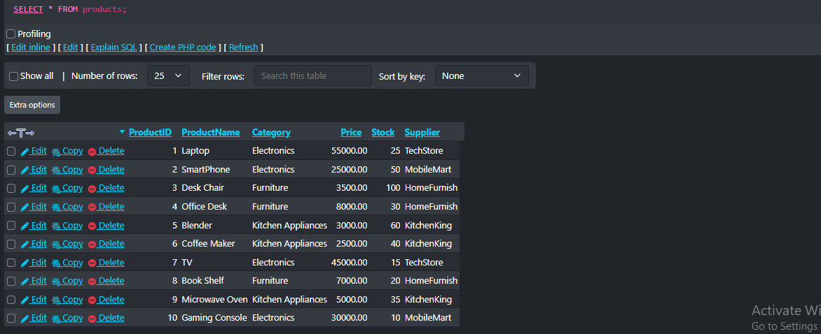

**2. Retrieve Specific Columns**

a. Write a query to display only the ProductName, Category, and Price columns from the Products table.

Query: SELECT ProductName, Category, Price FROM Products;

Answer (screenshot):

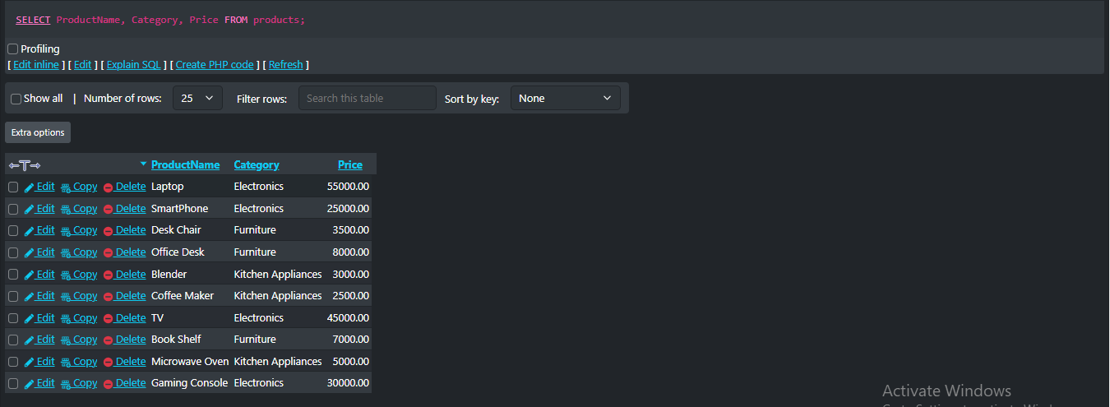

**3. Filter Rows Using WHERE**

1. Write a query to display all products in the "Electronics" category.

Query: SELECT * FROM Products WHERE Category = ‘’

Answer (screenshot):

1. Write another query to display all products priced above 20,000.

Query:

Answer (screenshot):

**4. Use Comparison Operators**

1. Write a query to display products with stock less than 30.

Query:

Answer (screenshot):

1. Write another query to display products with prices between 3,000 and 10,000.

Query:

Answer (screenshot):

**5. Use LIKE for Pattern Matching**

1. Write a query to find all products whose names start with "B."

Query:

Answer (screenshot):

1. Write another query to find products with "Desk" in their names.

Query:

Answer (screenshot):